Case 1:

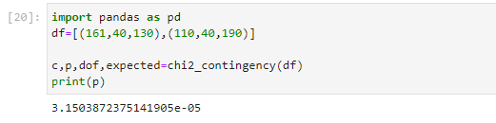

1. It is a null hypothesis.
2. The hypothesis is statistically significant and hence no association.

Case 2:

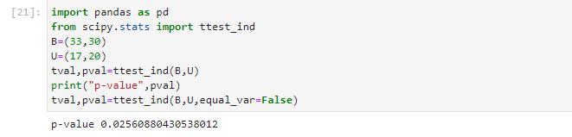

We reject the null hypothesis. And the data is independent.

Case 3:

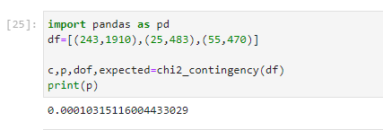

p-value is less than 0.05 hence the null hypothesis is rejected and the results are significant.

No association.

Case 4:

1. Contingency Table

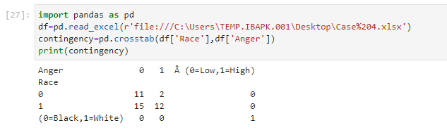

1. Chisquare Test

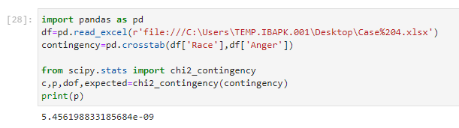

p-value is less than 0.05 hence the null hypothesis is rejected and the results are significant